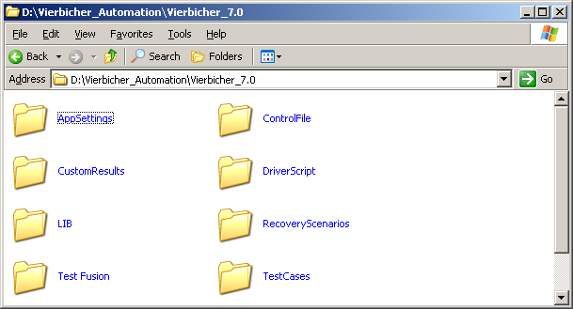

The Keyword Driven Framework consists of the basic components given below:

1. Control File
2. Test Case File
3. Startup Script
4. Driver Script
5. Utility Scripts

- Control File:

- Consists details of all the Test scenarios to be automated.
- User will be able to select a specific scenario to execute based on turning on or off a flag in the Control File.
- Control File is in the form of an excel worksheet and contains columns for Scenario ID, Execute (Y/N), Object Repository Path, Test Case File Path.

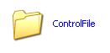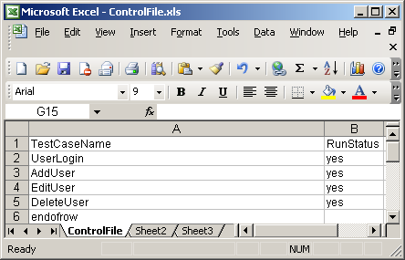

2. Test Case File:

- Contains the detailed steps to be carried out for the execution of a test case.
- It is also in the form of an excel sheet and contains columns for Keyword, Object Name, Parameter.

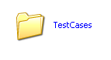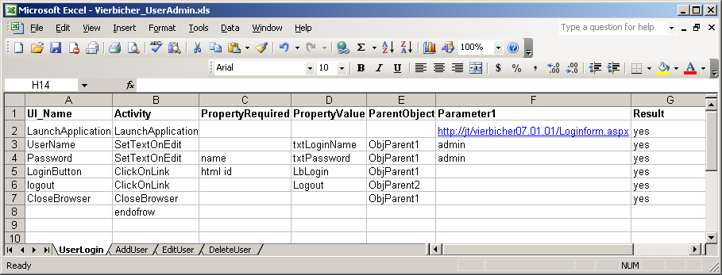

3. Startup Script:

- The Startup script is utilized for the initialization and reads the control files.
- It then calls the driver script to execute all the scenarios marked for execution in the control file.

4. Driver Script:

- It Reads the Test Case files. Checks the keywords and calls the appropriate utility script functions based on specific keyword.
- Error Handling is taken care of in the driver script.
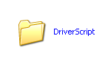

5.Utility Scripts:

- This folder Contains some type Utility of Functions.

Navigation:-

Start->Programs->QuickTest Profissional-> Click->File->Open->Browse for Folder->

Driver Script->Click

- Associates the All Library Files And Utility Files To the Resources.

Navigation:- Q.T.P->File->Settings->Test Settings->Resources->Libraries-> Click

Q.T.P Screen:
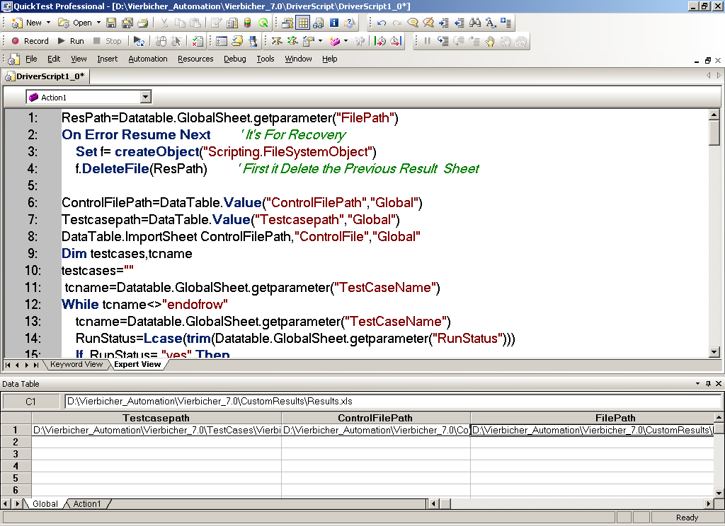

DRIVER SCRIPT ARCHITECTURE

Architecture Used for communicating between different modules.
Obj 1
Sub–Script1
Data Sheet 1
Result 1

Common Library Files

Exception Handling
Obj 2
Sub–Script2
Data Sheet 2
Result 2

Obj n
Sub–Script n
Data Sheet n
Result n
Main Data Excel Sheet
Driver Script

Scripts

Driver Script:

ResPath=Datatable.GlobalSheet.getparameter("FilePath")
On Error Resume Next ' It's For Recovery
Set f= createObject("Scripting.FileSystemObject")
f.DeleteFile(ResPath) ' First it Delete the Previous Result Sheet

ControlFilePath=DataTable.Value("ControlFilePath","Global")
Testcasepath=DataTable.Value("Testcasepath","Global")
DataTable.ImportSheet ControlFilePath,"ControlFile","Global"

Dim testcases,tcname
testcases=""

tcname=Datatable.GlobalSheet.getparameter("TestCaseName")

While tcname<>"endofrow"
tcname=Datatable.GlobalSheet.getparameter("TestCaseName")
RunStatus=Lcase(trim(Datatable.GlobalSheet.getparameter("RunStatus")))

If RunStatus= "yes" Then

If testcases=""Then
testcases=tcname

else
testcases=testcases+";"+tcname
End If
End If
DataTable.SetNextRow

Wend

tname=split(testcases,";")

For i= 0 to ubound(tname)
Status=false
datatable.ImportSheet Testcasepath,tname(i),"Action1"
FunctionName=Datatable.Localsheet.getparameter("Activity")
FunctionName=Lcase(trim(FunctionName))

While FunctionName<>"endofrow"

UIName=Datatable.Localsheet.getparameter("UI_Name")
FunctionName=Datatable.Localsheet.getparameter("Activity")
PropertyRequired=Datatable.Localsheet.getparameter("PropertyRequired")
PropertyValue=Datatable.Localsheet.getparameter("PropertyValue")
ObjParent=Datatable.Localsheet.getparameter("ParentObject")
Parameter1=Datatable.Localsheet.getparameter("Parameter1")
Result=Datatable.Localsheet.getparameter("Result")
FunctionName=Lcase(trim(FunctionName))
ObjParent=Trim(Lcase(ObjParent))

Select Case ObjParent ' It's For Setting the Parent Object

Case "objparent1"
Set ParentObject=Browser("title:=Vierbicher Associates Incorporated").
Page("title:=Vierbicher Associates Incorporated")
Case else
Set ParentObject=Browser("title:=[A-Z].*").Page("title:=[A-Z].*")
End Select

Select Case FunctionName ' It's For Calling the Library & Utility Functions

Case "clickonlink"
Call ClickOnLink(ParentObject,PropertyRequired,PropertyValue,Result)

Case "settextonedit"
ValueToSet=Parameter1
ret= SetTextOnEdit(ParentObject,PropertyRequired,PropertyValue,ValueToSet,Result)
If ret=-1 Then
Status=True
End If
Case "verifyvalueinedit"
ValueToVerify=Parameter1
ret= VerifyValueInEdit(ParentObject,PropertyRequired,PropertyValue,ValueToVerify,Result)

If ret=-1 Then
Status=True
End If

Case "launchapplication"
url=Parameter1
Call LaunchApplication(url)

Case "closebrowser"
Call CloseBrowser(ParentObject)

Case "findmessageonbrowser"
messagetoverify=PropertyValue
ret= FindMessageOnBrowser(ParentObject,PropertyRequired,messagetoverify,Result)

If ret=-1 Then
Status=True
End If

Case "selectiteminlist"
ValueToSelect=Parameter1
Call SelectItemInList(ParentObject,PropertyRequired,PropertyValue,ValueToSelect,Result)

Case "selectradiogroup"
RadioToSelect=Parameter1
Call SelectRadioGroup(ParentObject,PropertyRequired,PropertyValue,RadioToSelect,Result)

Case "setcheckbox"
CheckboxToSet=Parameter1
Call SetCheckBox(ParentObject,PropertyRequired,PropertyValue,CheckboxToSet,Result)

Case "webbutton"
Call WebButton(ParentObject,PropertyRequired,PropertyValue,Result)
End Select

DataTable.SetNextRow

Wend

TestcaseName=tname(i)
FilePath=ResPath
If Status=false then
Status=false
Else
Status=true
End if
Call CustomResult(FilePath,TestcaseName,Status)
Next
Library Functions:
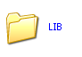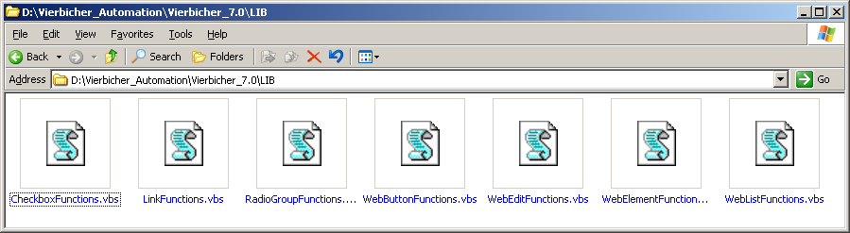

AppSettings Or A.O.M Settings :

- Before Generating a test script we can Change the Q.T.P Tool Settings Based on your Convinent And Application.
Those are Test Settings, Option Settings And Object Identification Settings.

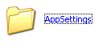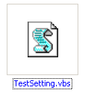
CheckboxFunctions.vbs

Function SetCheckBox(ParentObject,PropertyRequired,PropertyValue,CheckboxToSet,Result)
Call ReportResult(Result)
Dim hit
hit=0
If PropertyRequired="" then
PropertyRequired="name"
End If

If ParentObject.WebCheckBox(PropertyRequired&":="&PropertyValue).exist then
ParentObject.WebCheckBox(PropertyRequired&":="&PropertyValue).set CheckboxToSet
hit=1
End if

If hit>0 then
Reporter.reportevent micpass,"The Check: "&CheckToSet&" in the Check: "&PropertyValue,
"selected sucessfully"
else
Reporter.reportevent micfail,"The Check: "&CheckToSet&" in the Check:"&PropertyValue &"Not selected",
"May be object not exist or not indetified"
End if
End Function

LinkFunctions.vbs
Function ClickOnLink(ParentObject,PropertyRequired,PropertyValue,Result)
Call ReportResult(Result)
Dim hit
hit=0
If PropertyRequired="" then
PropertyRequired="innertext"
End If
If ParentObject.Link(PropertyRequired &":="&PropertyValue).exist then
ParentObject.Link(PropertyRequired &":="&PropertyValue).click
hit=1
End if

If hit>0 then
Reporter.reportevent micpass,"The link: "&PropertyValue,"Clicked sucessfully"
else
Reporter.reportevent micpass,"The link: "&PropertyValue,"not Clicked sucessfully"
End if
End Function

RadioGroupFunctions.vbs

Function SelectRadioGroup(ParentObject,PropertyRequired,PropertyValue,RadioToSelect,Result)
Call ReportResult(Result)
Dim hit
hit=0
If PropertyRequired="" then
PropertyRequired="name"
End If

If ParentObject.WebRadioGroup(PropertyRequired&":="&PropertyValue).exist then
ParentObject.WebRadioGroup(PropertyRequired&":="&PropertyValue).select RadioToSelect
hit=1
End if

If hit>0 then
Reporter.reportevent micpass,"The Radio: "&RadioToSelect&" in the Radiogroup: "&PropertyValue,
"selected sucessfully"
else
Reporter.reportevent micfail,"The Radio: "&RadioToSelect&" in the Radiogroup: "&PropertyValue &
"Not selected","May be object not exist or not indetified"
End if
End Function

WebButtonFunctions.vbs
Function WebButton(ParentObject,PropertyRequired,PropertyValue,Result)
Call ReportResult(Result)
Dim hit
hit=0
If PropertyRequired="" then
PropertyRequired="name"
End If

If ParentObject.WebButton(PropertyRequired &":="&PropertyValue).exist then
ParentObject.WebButton(PropertyRequired &":="&PropertyValue).click
hit=1
End if

If hit>0 then
Reporter.reportevent micpass,"The button: "&PropertyValue,"Clicked sucessfully"
else
Reporter.reportevent micpass,"The button: "&PropertyValue,"not Clicked sucessfully"
End if
End Function

WebEditFunctions.vbs
Function SetTextOnEdit(ParentObject,PropertyRequired,PropertyValue,ValueToSet,Result)
Call ReportResult(Result)
Dim hit
hit=0
If PropertyRequired="" then
PropertyRequired="name"
End If

If ParentObject.Webedit(PropertyRequired&":="&PropertyValue).exist then
ParentObject.Webedit(PropertyRequired&":="&PropertyValue).set ValueToSet
hit=1
End if
If hit>0 then
Reporter.reportevent micpass,"The valeu in the edit box: "&PropertyValue,"Entered sucessfully"
SetTextOnEdit="stepPass"
else
Reporter.reportevent micfail,"The valeu in the edit box: "&PropertyValue &"Not entered",
"May be object not exist or not indetified"
SetTextOnEdit=-1
End if

End Function

Function VerifyValueInEdit(ParentObject,PropertyRequired,PropertyValue,ValueToVerify,Result)
Call ReportResult(Result)
Dim hit
hit=0
If PropertyRequired="" then
PropertyRequired="name"
End If

If ParentObject.Webedit(PropertyRequired&":="&PropertyValue).exist then
If trim(Lcase(ParentObject.Webedit(PropertyRequired&":="&PropertyValue).getRoproperty("value")))=
trim(Lcase(ValueToVerify)) then
hit=1
End if
End if

If hit>0 then
Reporter.reportevent micpass,"The valeu in the edit box: "&PropertyValue,"matches with the veriedtest"
else
Reporter.reportevent micfail,"The valeu in the edit box: "&PropertyValue &"Not entered",
"May be object not exist or not indetified"
End if

End Function
WebElementFunctions.vbs

Function FindMessageOnBrowser(ParentObject,PropertyRequired,messagetoverify,Result)
Call ReportResult(Result)
Dim hit
hit=0

If PropertyRequired="" then
PropertyRequired="innertext"
End If

If ParentObject.webelement(PropertyRequired&":="&messagetoverify).exist then
hit=1
End if

If hit>0 then
Reporter.reportevent micpass,"The message: "&messagetoverify,"found in browser"
FindMessageOnBrowser="setppass"
else
Reporter.reportevent micfail,"The message: "&messagetoverify," not found in browser"
FindMessageOnBrowser=-1
End if
End Function
WebListFunctions.vbs
Function SelectItemInList(ParentObject,PropertyRequired,PropertyValue,ValueToSelect,Result)
Call ReportResult(Result)
Dim hit
hit=0
If PropertyRequired="" then
PropertyRequired="name"
End If
If ParentObject.WebList(PropertyRequired&":="&PropertyValue).exist then
ParentObject.WebList(PropertyRequired&":="&PropertyValue).select ValueToSelect
hit=1
End if

If hit>0 then
Reporter.reportevent micpass,"The valeu in the list box: "&PropertyValue,"selected sucessfully"
else
Reporter.reportevent micfail,"The valeu in the list box: "&PropertyValue &"Not selected",
"May be object not exist or not indetified"
End if
End Function

Utility Functions:
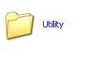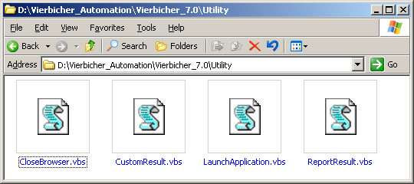
CloseBrowser.vbs
Function CloseBrowser(ParentObject)
pval=ParentObject.getRoProperty("title")
Browser("title:="&pval).close
End function
CustomResult.vbs

'******************************************************************************************
'Function Name : MakePath.
'Description : This Function creates the result file in XLS
' format and formats the Header section.
'Parameter : This function takes the following parameters.
' oFso : Instance of FileSystemObject
' sPath : Required path (must be fully qualified)
' Returns : True - Path now exists
' False - Path does not exist
'******************************************************************************************

Function MakePath(oFso, sPath)
' Default result
MakePath = False

' Fail if drive is not valid
If Not oFso.DriveExists(oFso.GetDriveName(sPath)) Then Exit Function

' Succeed if folder exists
If oFso.FolderExists(sPath) Then
MakePath = True
Exit Function
End if

' Call self to ensure parent path exists
If Not MakePath(oFso, oFso.GetParentFolderName(sPath)) Then
Exit function
End if

' Create folder
On Error Resume next
oFso.CreateFolder sPath
MakePath = oFso.FolderExists(sPath)
End function
'******************************************************************************************
'Function Name : CreateResultFile
'Description : This Function creates the result file
in XLS format and formats the Header section
'Parameter : This function takes the following parameters
'FilePath (String) : Path of the result file
'******************************************************************************************

Function CreateResultFile(FilePath)
'Create an object of Excel application
Dim appExcel
Set appExcel = CreateObject("Excel.Application")

'Disable alerts
appExcel.DisplayAlerts = False

'Add a workbook to the Excel App
appExcel.Workbooks.Add

'Get the object of the first sheet in the workbook
Set objSheet = appExcel.Sheets("Sheet1")
appExcel.Sheets("Sheet1").Select

'Rename the first sheet to "Test_Summery"
objSheet.Name = "Test_Summary"

'Set the Heading
objSheet.Range("B1").Value = "Test Results"
objSheet.Range("B1:C1").Merge

'Set color and Fonts for the Header
objSheet.Range("B1:C1").Interior.ColorIndex = 53
objSheet.Range("B1:C1").Font.ColorIndex = 19
objSheet.Range("B1:C1").Font.Bold = True

'Set the Date and time of Execution
objSheet.Range("B3").Value = "Test Date: "
objSheet.Range("B4").Value = "Test Start Time: "
objSheet.Range("B5").Value = "Test End Time: "
objSheet.Range("B6").Value = "Test Duration: "
objSheet.Range("C3").Value = Date
objSheet.Range("C4").Value = Time
objSheet.Range("C5").Value = Time
objSheet.Range("C6").Value = "=R[-1]C-R[-2]C"
objSheet.Range("C6").NumberFormat = "[h]:mm:ss;@"

'Set the Borders for the Date & Time Cells
objSheet.Range("B3:C8").Borders(1).LineStyle = 1
objSheet.Range("B3:C8").Borders(2).LineStyle = 1
objSheet.Range("B3:C8").Borders(3).LineStyle = 1
objSheet.Range("B3:C8").Borders(4).LineStyle = 1

'Format the Date and Time Cells
objSheet.Range("B3:C8").Interior.ColorIndex = 40
objSheet.Range("B3:C8").Font.ColorIndex = 12
objSheet.Range("B3:A8").Font.Bold = True

'Track the Row Count and insrtuct the viewer not to disturb this
objSheet.Range("C7").AddComment
objSheet.Range("C7").Comment.Visible = False
objSheet.Range("C7").Comment.Text "This is a very Important field for the script."
& vbcrlf & "Please Do not Edit or Delete."
objSheet.Range("C7").Value = "0"
objSheet.Range("B7").Value = "No Of Scenarios:"
objSheet.Range("B8").Value = "TotalScenariosPassed"
objSheet.Range("B9").Value = "TotalScenariosFailed"
objSheet.Range("B10").Value = "ScenarioName"
objSheet.Range("C10").Value = "Status"
objSheet.Range("B2:C2").Interior.ColorIndex =20
'Format the Heading for the Result Summery
objSheet.Range("B10:C10").Interior.ColorIndex = 53
objSheet.Range("B10:C10").Font.ColorIndex = 19
objSheet.Range("B10:C10").Font.Bold = True
objSheet.Range("B8:C8").Interior.ColorIndex =20
objSheet.Range("B8:C8").Font.ColorIndex = 50
objSheet.Range("B8:C8").Font.Bold = True
objSheet.Range("B9:C9").Interior.ColorIndex =20
objSheet.Range("B9:C9").Font.ColorIndex = 3
objSheet.Range("B9:C9").Font.Bold = True

'Set the Borders for the Result Summery
objSheet.Range("B10:C10").Borders(1).LineStyle = 1
objSheet.Range("B10:C10").Borders(2).LineStyle = 1
objSheet.Range("B10:C10").Borders(3).LineStyle = 1
objSheet.Range("B10:C10").Borders(4).LineStyle = 1

'Set Column width
objSheet.Columns("B:C").Select
objSheet.Columns("B:C").Autofit
objSheet.Range("B11").Select

'Freez pane
appExcel.ActiveWindow.FreezePanes = True

'Save the Workbook at the specified Path with the Specified Name
appExcel.ActiveWorkbook.saveas FilePath

'Close Excel
appExcel.quit
'Relese the Object
Set objSheet = Nothing
Set appExcel = Nothing
End Function
''******************************************************************************************
'Function Name : ReportResult.
'Description : This function writes the result to the result file on the
' last row.
'Parameter : This function takes the following parameters.
'FilePath (String) : Path of the result file.
'TestcaseName (String) : Name of the test case.
'StepName (String) : Name of the step for which the result is being written.
'Description (String) : Description of the step for which the result is being ' ' written.
'Status (Boolean) : Status of the Step (0 = Pass and 1 = Fail).
'Expected (String) : Expected result for the step.
'Actual (String) : Actual Result for the step.
'MSG (String) : Error Message.
'******************************************************************************************

Function CustomResult(FilePath, TestcaseName,Status)
'If the Result File Does not exist, Create the one
Dim filesys
Set filesys = CreateObject("Scripting.FileSystemObject")
If Not filesys.FileExists(FilePath) Then
ParentFolder = filesys.GetParentFolderName(FilePath)
If Not filesys.FolderExists(ParentFolder) Then
MakePath filesys, ParentFolder
End IF
CreateResultFile(FilePath)
End If
Set filesys = Nothing

'Create an Excel Object
Dim appExcel
Set appExcel = CreateObject("Excel.Application")

'Open the Result file
Set objWorkBook = appExcel.Workbooks.Open (FilePath)

'Select the Summery Sheet
Set objSheet = appExcel.Sheets("Test_Summary")
appExcel.Sheets("Test_Summary").Select

'Note the Row No on which to Report the result
Row = objSheet.Range("C8").Value + 2*objSheet.Range("C7").Value + 2
TCRow = objSheet.Range("C7").Value + 11
NewTC = False

'Check if it is a new Tetstcase
If objSheet.Cells(TCRow - 1, 2).Value <> TestcaseName Then
objSheet.Cells(TCRow, 2).Value = TestcaseName
appExcel.ActiveSheet.Hyperlinks.Add objSheet.Cells(TCRow, 2), "", "Test_Result!A" & Row+1, TestcaseName
If cBool(Status) then
objSheet.Cells(TCRow, 3).Value = "FAILED"
objSheet.Range("C" & TCRow).Font.ColorIndex = 3
objSheet.Range("C9").Value = objSheet.Range("C9").Value + 1
Else
objSheet.Cells(TCRow, 3).Value = "PASSED"
objSheet.Range("C8").Value = objSheet.Range("C8").Value + 1
objSheet.Range("C" & TCRow).Font.ColorIndex = 50
End If

NewTC = True
objSheet.Range("C7").Value = objSheet.Range("C7").Value + 1

'Set the Borders for the Result Header
End If

If (Not NewTC) and (cBool(Status)) then
objSheet.Cells(TCRow-1, 3).Value = "Fail"
objSheet.Range("C" & TCRow-1).Font.ColorIndex = 3
End If
'Update the End Time
objSheet.Range("C5").Value = Time

'Set Column width
objSheet.Columns("B:C").Select
objSheet.Columns("B:C").Autofit
appExcel.Sheets("Test_Summary").Select
appExcel.Sheets("Test_Summary").Range("B1").Select

'Save the Workbook
objWorkBook.Save
set objWorkBook = Nothing

'Close Excel
appExcel.Quit

'Free the Object
Set appExcel = Nothing
End Function

LaunchApplication.vbs

Function LaunchApplication(url)
SystemUtil.Run "Explorer.exe",url
End Function

ReportResult.vbs

Function ReportResult(Result)
If Result="yes" then
Reporter.filter=0
else
Reporter.filter=3
End if
End Function

CustomResults Folder

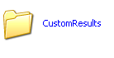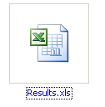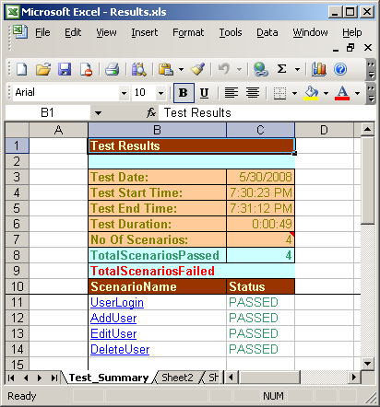
Test Fusion Report:

